Eric Christopher / 15M53531
Xor Gate
There are 2 possibilities (using gate logic):
A
B
Input Layer
Hidden Layer
Output Layer
A
B
Input Layer
Hidden Layer
Output Layer
But I tried another possibility using neural network (not depend on gate logic)
- Using 3 nodes
same with the 2, but using NAND (X2 is NAND gate) instead of AND and NOT gate
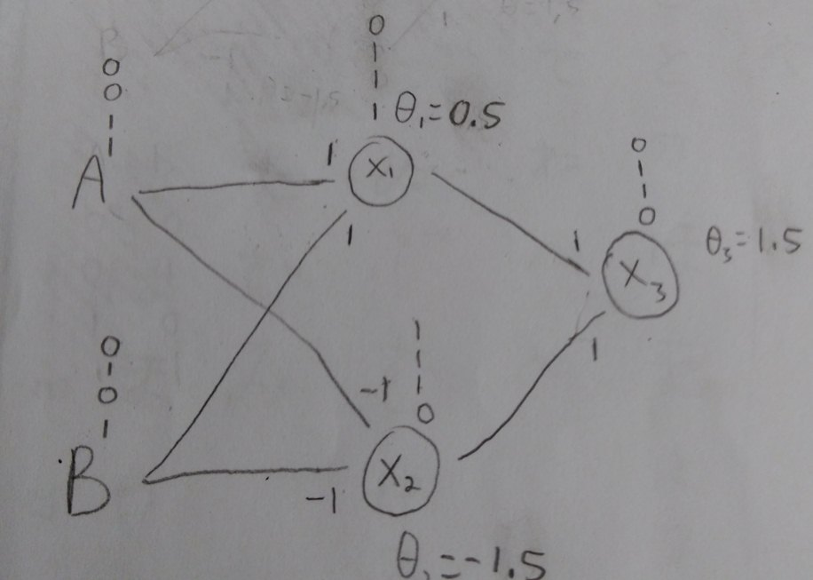
- Using 2 nodes
The X2 node need 3 input instead of 2
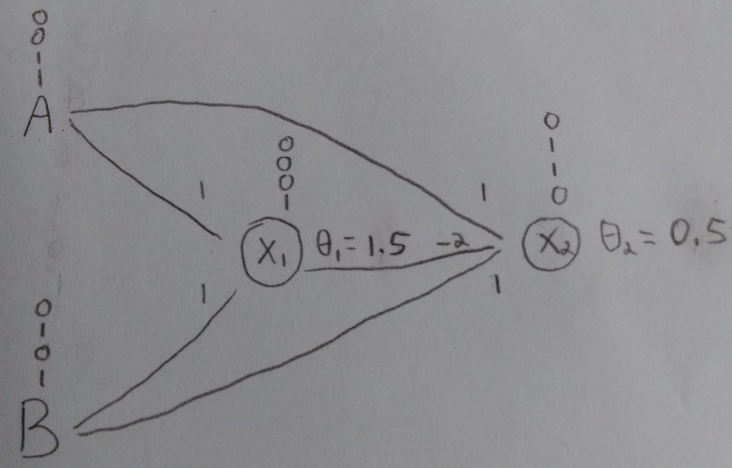
Many ways to create XOR gate, after a few trying, I can’t make it 1 node, so my best is using 2 nodes to create XOR gate.
For winner takes all, in my experience, we need to check each node at least once
Because I found that our program can be stopped before we get all 0 except 1 node 1
Here is the case
Input: 1,0,1,1,1 , all weight=-1, all threshold=-1,5
Result:
--(1,0,1,1,1) - E=4.0
=================================================
-change node 1
--S=-3.0
--(0,0,1,1,1) - E=1.5
=================================================
-change node 2
--S=-3.0
--(0,0,1,1,1) - E=1.5⬅======================== we will stop in this step because this node same with the previous one
=================================================
-change node 3
--S=-2.0
--(0,0,0,1,1) - E=0.0
=================================================
-change node 4
--S=-1.0
--(0,0,0,0,1) - E=-0.5
=================================================
-change node 5
--S=0.0
--(0,0,0,0,1) - E=-0.5
=================================================
-change node 1
--S=0.0
--(0,0,0,0,1) - E=-0.5
=================================================
=======================END=======================
=================================================

Prove for E always decrease if we try to change input in deterministic and binary model
